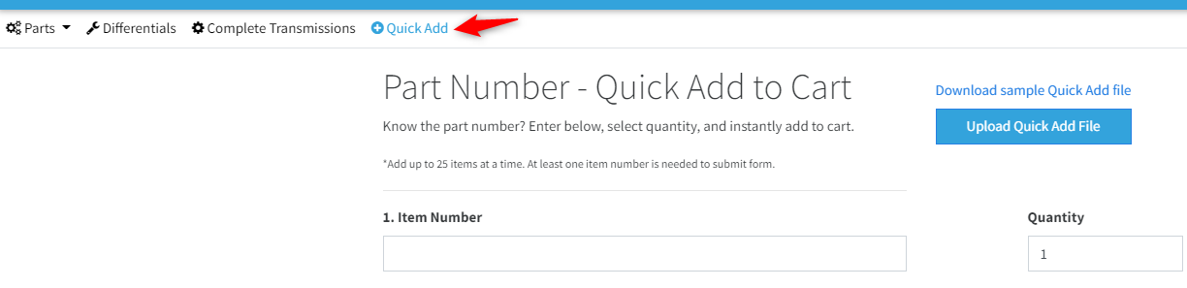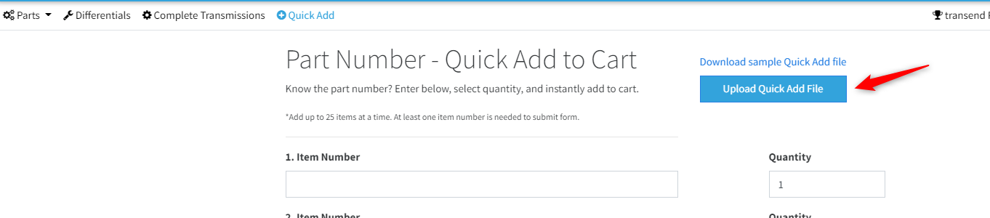
In excel, when you "Save As" create you file name and then select the file type

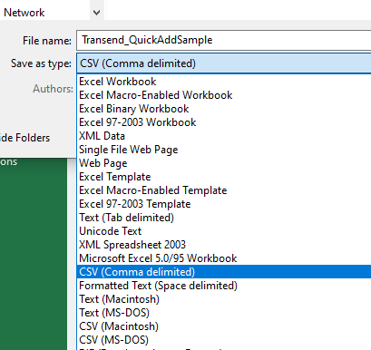
Once your Excel file is created, you would go to this section and upload your file

